WINTER SAFETY
Be Part of Our Team

*Before the Snow Falls*

Beginning as early as September, The North Castle Highway Department begins preparing for winter months ahead by reviewing snow removal routes and servicing equipment. Preparation and servicing of equipment for the upcoming winter continues through November.

In order to be properly prepared for inclement weather during snow seasons, the Highway Department continually monitors daily weather conditions via satellite and receives daily weather reports from Weather Works Inc.

Depending on how the storm develops, you might see our crews prewetting the roadways up to five days before. Please stay back 500’ and do not pass our trucks, this is for your safety and not having your vehicle sprayed. The most cost effective prewetting and liquid solutions can be made from sodium chloride and water to form salt brine. The eutectic composition of sodium chloride & water is 23% NaCI and 77 % H@) by weight, which freezes at about -21 C (-6 F).

MORE ON SALT BRINE

**When the Snowfall Starts**
An important step in dealing with snowfall is street salting. Top priority is given to the towns’ main roads. Those roads are routes that the town has found to have the heaviest year-round traffic and usually are major arteries running north/south or east/west and have double yellow centerlines.
The snow removal process starts when frozen precipitation begins falling. Operations initiate with the application of materials to the roads and continue until the material application is no longer effective due to the depth of the snow.

***When the Snowfall Continues***
When two or three inches of snow have accumulated and more is expected, snow is more economically removed by plowing rather than applying material. All public roads, main thoroughfares and residential streets will be plowed by Highway Department personnel. Our first responsibility is to open main roads. These arterials are the key to providing safe access for emergency vehicles as well as maintaining the steady flow of traffic since most residents live within a few blocks of such a route. The plows then continue to all streets on the route to “open up” each on in sequence. If the storm continues in intensity, the trucks remain in that same pattern until storm abates. At that time, the trucks begin to “widen out” all roads by pushing the accumulated snow back to the curb line and clearing intersections. Remember, trained crews work around the clock during these storms to keep the roads open and passable. If you wish to report a hazardous condition call the Highway Department at 273-3561 Ext. 45. If there is a medical emergency, call 911 or contact the North Castle Police Department at 273-9500.

****After the Storm is Over****
Crews continue to monitor all roads for icy spots and areas where winds redeposit the snow in traffic lanes. Usually an application of salt is applied to all streets so the riding surface remains drive able. If the accumulation is particularly heavy, the Town removes the snow from business districts. Crews are also dispatched to clear storm sewers so that melting snow can run off. You may wish to avoid a potential problem and also be of assistance to your neighbors by cleaning off a storm sewer or shoveling out a fire hydrant. As soon as practicable after the storm, sidewalks are treated or plowed to allow for pedestrian traffic. Please avoid creating a hazard by discarding snow from your driveway or sidewalk into the roadway.

Helpful hints on plowing and/or shoveling snow.

- When shoveling out the mouth of your driveway, throw it to the right of your driveway as you face the street or “downstream”. Throwing or plowing snow in the road or across the road can create a patch of snow and ice that freezes over and causes a hazardous condition and it is also illegal. Please inform your snow plow drivers that you and them can receive a summons for this action.
- If at all possible, finish clearing driveway entrance after the final widening pass has been complete. Helpful Hint: Leave a trip of snow at the edge of your driveway; this will block some of the snow from entering your driveway when the plow widens the roadway. The final widening pass is usually complete approximately 4 to 6 after the snow stops completely. This, of course, depends on the severity of the storm.

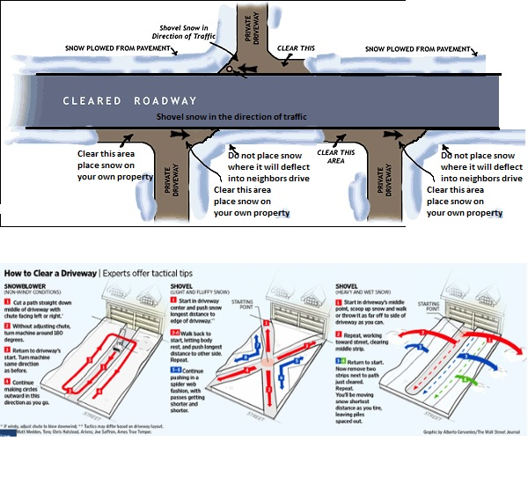
WINTER TIPS AND SUGGESTIONS
- Plan alternate ways and extra time to travel to main routes and to your place of employment.
- Remember! Slow down, brake slowly and allow plenty of room between you and the vehicle ahead of you.
- During times of reduced visibility, watch for pedestrians, bicycles and disable vehicles.
- Please do not set your garbage cans in the road, as the plows must work around them, crossing the centerline of the road in the process.
- Do not park vehicles in the road or cul de sac’s, this makes it impossible to properly clear the snow from these areas.
- Be neighborly! Volunteer to shovel snow for elderly and disable residents who can’t clear their walks.
- When out walking always were bright colored clothing.
- If you hire a snowplow contractor and they are leaving snow in the roadway or piling snow in cul-de-sacs or on the berm, please inform them of the inherent problems and dangers these actions can cause. This action is also illegal and you and the snow plow driver can receive a citation for this. By working together we can make this a safe winter season.
- It is in violation of the town of North Castle Town Code and New York State Vehicle and Traffic law for homeowners or your contractor to shovel or plow snow into the street. It is the property owners’ responsibility to make sure their plowing contractors are aware of these laws. Any violations will be reported to the Police Department for proper action.
- Snow left out in the road by homeowners or private snow plowers is a road hazard. We have all come upon this situation where we are driving along and come across a wall of snow trailing out of a driveway across the road. Snow should never be plowed onto or across the roadway. The proper way to plow a driveway is to start at the mouth of the drive and plow in. There should be a designated area to store snow in yard.
- Another danger is when snow is pushed across the road and piles on the berm. As the winter progresses these piles work their way out into the road. This hard-packed snow can push a snow plow across the centerline into on-coming traffic. All homeowners and snowplow contractors should be aware that they can be cited for palceing obstructions, including snow, on the roadway.
- Do not be confused by plow trucks riding with their plows up. They may be going in for fuel, repairs or headed for another area.
- Finally, please be patient. The Town has approximately 188 lane miles plus 16 lane miles of county and 57 lane miles of State for a total 261 lane miles of roadway to clear. Snow removal is an arduous and time consuming job; we strive to accomplish this task in a safe and timely manner.

Article IV, Snow Emergencies 325-32:
“The purpose of this article is to facilitate the removal of snow and ice from highways in the Town of North Castle and to prevent delay and traffic congestion attendant upon connected with parking vehicles.”
325-37:
No vehicle shall be allowed or permitted to be parked, stored or kept unattended on any Town Highway or other highway within the town of North Castle from 1:00am to 6:00am during the period from November 15 to April 1st.
325-39:
It shall be unlawful for any person to deposit, throw, drain or otherwise allow to accumulate water, snow or ice upon any highway or in or upon the gutter or grass area adjoining any highway.

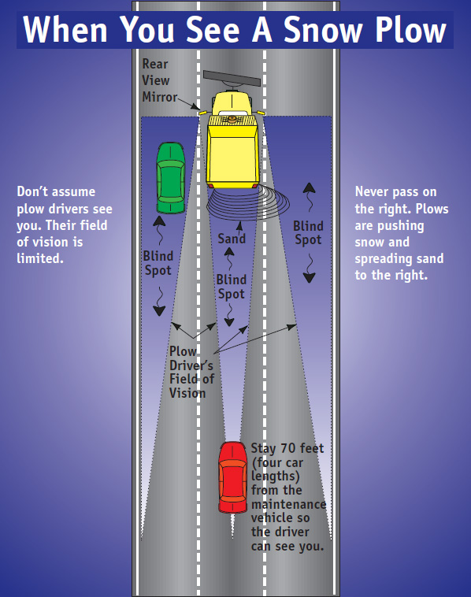

BROKEN OR DAMAGED PROPERTY
This is a common problem and a source of much confusion. Each street is a public right of way (ROW); this ROW may extend 6 to 10 feet or more beyond the paved surface. In most cases people do not know the exists or they simply ignore the fact and plant or place objects in the ROW. Generally speaking the town is not responsible for any type of damage to any item including mailboxes located in this area. Residents should review their property records and become familiar with actual boundaries.

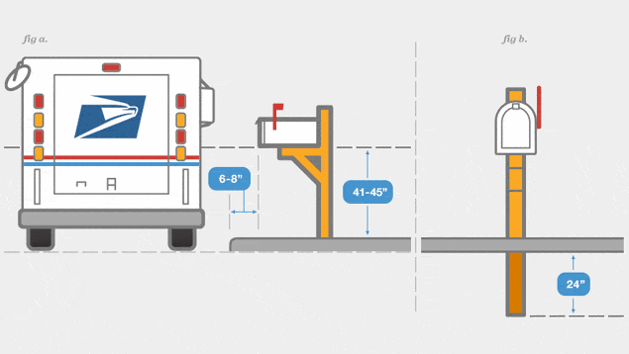

MAILBOXES
Our plow drivers are warned to take all precautions to avoid striking mailboxes with the wing of the plow and or snow. Above are some tips for mailbox placement to help reduce the chances of damage during winter plowing.
- Mailboxes should be shoveled out so they are clearly visible. Place reflective material on the side of the box visible to approaching traffic, also 3” high reflective letters to identify the address is recommended to assist emergency vehicles. Mailbox post size must not exceed 4” by 4” for a wooden post. Posts that are more substantial in construction are considered “dead fixed objects” and are not permitted within the town right-of-way. It is also prudent to check post for rot or deterioration, particularly at the base to insure they will not break under the weight of snow. At times, heavy slush discharged from a plow will knock down a mailbox. Most mailboxes, if properly placed and installed, will withstand heavy slush. The Town will NOT be responsible for damage done to a mailbox knocked down by heavy snow or slush. Before winter, please make sure that your mailbox is properly fastened to the pole. If we do damage your mailbox or post while plowing, we ask you to attempt to make any needed repair on your own. We will certainly do our best to help if you are elderly or unable, but we may not be able to send someone out to do the repairs for several days. Your assistance is needed in removing the snow from in front of your mailbox.
- Placing the mailbox on the side of your driveway away from approaching traffic will allow our driver to properly clear the roadway and to get as close as possible to your mailbox to minimize the amount of shoveling you will have to do to clear the mailbox for the postal carrier.

